**APWorks 2024-02**

**Technical Requirements**



Nexelus USA  
New York, NEW YORK (NY)  
646-558-1950

April 18, 2024

|  |  |  |  |
| --- | --- | --- | --- |
| **Revisions** | | | |
| **Date** | **Version Number** | **Revised By** | **Reason for Changes** |
| **4/18/2024** | **0.1** | **Tauseef** | **Initial Draft** |
|  |  |  |  |
|  |  |  |  |
|  |  |  |  |

Contents

Introduction 1

Invoice Editing Changes 2

Merge Invoice Lines 2

Process: 2

Assign Multiple IO/PO to Same Invoice line 3

Dashboard Changes 4

Expand Dashboard Layout 4

Master Data Editing 6

# Introduction

This document covers changes requested by Plus Company.

# Media Invoice Editing Changes

The following changes will be made to Invoice Editing.

* Merge Invoice Lines
* Assign Multiple PO to Invoice Line
* Switch between Media/Broadcast Invoices

## Merge Invoice Lines

Application will allow merging multiple invoice lines with same PO/IO number.

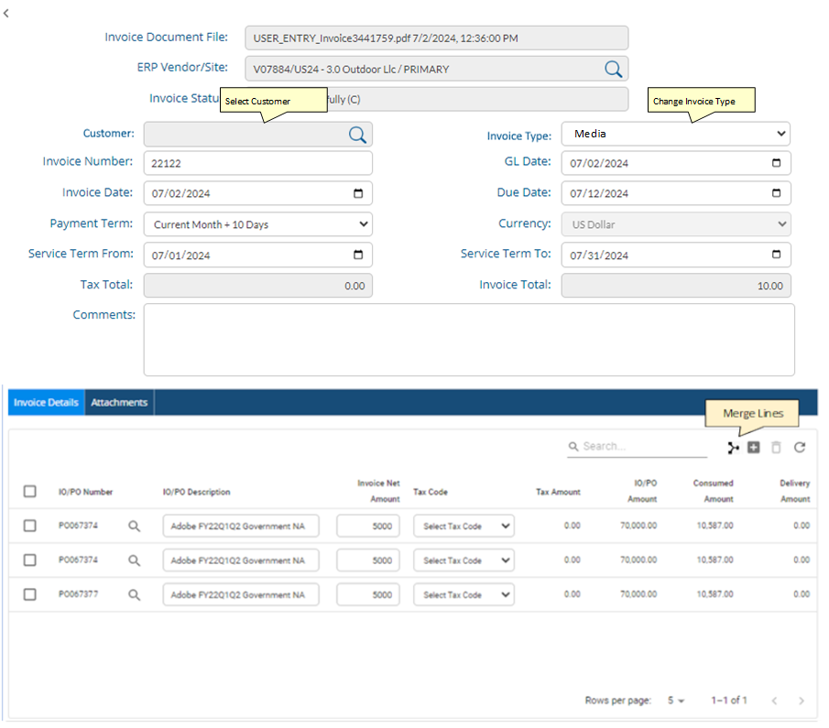

### Process:

The user will select checkboxes against multiple lines and click merge button. If PO number is same against the selected lines, Invoice Net Amount and Tax Amount will sum up for these lines in first selected line and delete the remaining lines from invoice detail grid.

Note: The IO/PO number must be the same for all selected lines. If selected lines do not have same IO/PO number, the merge button will be disabled.

## Assign Multiple IO/PO to Same Invoice line

This feature allows assigning multiple IO/PO numbers to the same invoice line.

When user clicks on search button for IO/PO number, the popup Dialog will allow selecting more than one IO/PO number. This will be allowed only if multiple invoice lines are not selected. Otherwise only one IO will be allowed to be selected as the system is currently working.

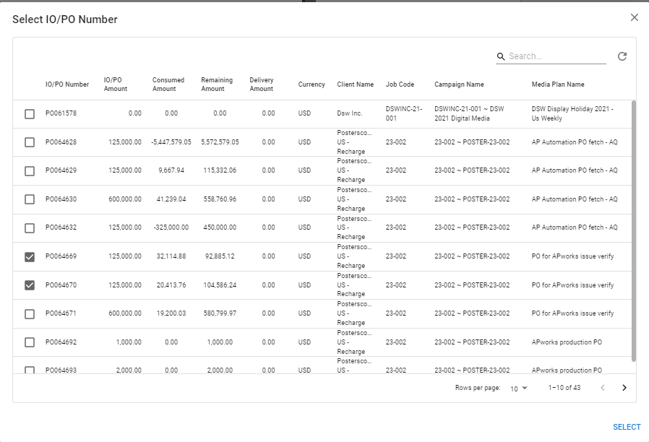

When a user selects a single IO/PO number, there will be no change in the current behavior of the application. However, if user selects multiple IO/PO numbers, system will verify if sum of remaining amount for selected IO/PO numbers is same as invoice line amount. If the amount is not the same, then a warning message will be displayed. However, if both values are same, then the system will create additional copies of invoice lines (Sum of selected PO lines minus one) and assign selected IO/PO numbers to selected invoice line and newly created lines.

## Change Invoice Type

A new field is added in Invoice to change invoice type between Media and Broadcast invoices.

## Select Client

Client Lookup is added in Media Invoices. This is a non-mandatory field. However, if a client has been specified on an invoice, all PO/IO for this client can be used in this invoice.

## Changes in Invoice Approval

If an invoice has client defined for an invoice, resources mapped for this client can perform invoice approvals based on roles assigned to these resources for client, and service type. Otherwise, any user with relevant group role can approve the invoice.

# Dashboard Changes

## Expand Dashboard Layout

APWorks layout shows four sections for invoices.

1. Invoice Queue
2. Discrepant Invoices
3. Pending Approval
4. Approved Invoices

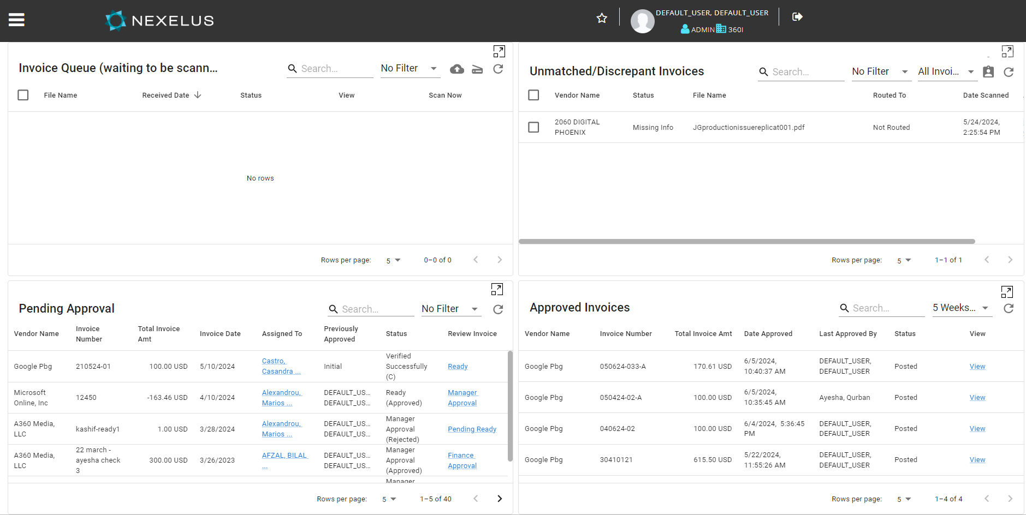

Due to screen size limitation, these sections show only five rows each on screen. It is proposed to add an expand button, which expands a section to cover most of the desktop area and shows 25 lines by default.

The expand button on top of each section will expand it and show over the Dashboard section. The Pop section will show a close button to hide the dialog.

# New Master Data

Following new Master Data will be added to APWorks, to incorporate changes for Plus Company

## Company Configuration

Syncing of Master data from ERP system will be based on configuration in Company UI/ Table. This includes following:

1. Taxes
2. Payment Terms
3. Currencies
4. Media Type
5. Service type

The company UI will have following section to configure Data Sync for each table.

The data will be synced from ERP, based on flag set in company table. If the flag is set to Edit, then users will be allowed to add/edit/delete for these categories in APWorks.

## Table Changes / Additions

### Media Types

**Table: apad_media_type**

Sync source from Nexelus: pdd_service_type_grp_hdr

|  |  |  |  |  |  |
| --- | --- | --- | --- | --- | --- |
| **Field** | **Type** | **Len** | **Unique** | **NN** | **PK** |
| Company_code | Int |  |  | Y | Y |
| media_type_id | Varchar | 32 |  | Y | Y |
| media_type_desc | Varchar | 128 |  | Y |  |
| IsActive | Bit |  |  |  |  |
| Create_id | Varchar | 32 |  |  |  |
| Create_date | Datetime |  |  |  |  |
| Modify_id | Varchar | 32 |  |  |  |
| Modify_date | DateTime |  |  |  |  |
| Row_id | Int |  |  |  |  |

### Service Types

**Table: apad_service_type**

Sync source from Nexelus: pdd_service_type_grp_dtl

|  |  |  |  |  |  |
| --- | --- | --- | --- | --- | --- |
| **Field** | **Type** | **Len** | **Unique** | **NN** | **PK** |
| Company_code | Int |  |  | Y | Y |
| Media_type_id | Varchar | 32 |  | Y | Y |
| Service_type_id | Varchar | 32 |  | Y |  |
| Create_id | Varchar | 32 |  |  |  |
| Create_date | Datetime |  |  |  |  |
| Modify_id | Varchar | 32 |  |  |  |
| Modify_date | DateTime |  |  |  |  |
| Row_id | Int |  |  |  |  |

### Clients

**Table: apad_customer**

Sync Source from Nexelus: pdv_customer

|  |  |  |  |  |  |
| --- | --- | --- | --- | --- | --- |
| **Field** | **Type** | **Len** | **Unique** | **NN** | **PK** |
| Company_code | Int |  |  | Y | Y |
| Customer_code | Varchar | 16 |  | Y | Y |
| Customer_name | Varchar | 64 |  | Y |  |
| IsActive | Bit |  |  |  |  |
| Create_id | Varchar | 32 |  |  |  |
| Create_date | Datetime |  |  |  |  |
| Modify_id | Varchar | 32 |  |  |  |
| Modify_date | DateTime |  |  |  |  |

### Clients Resources

**Table: apad_customer_resource**

Synce Source from Nexelus: pdd_customer_resource

|  |  |  |  |  |  |
| --- | --- | --- | --- | --- | --- |
| **Field** | **Type** | **Len** | **Unique** | **NN** | **PK** |
| Company_code | Int |  |  | Y | Y |
| Customer_code | Varchar | 32 |  | Y | Y |
| Resource_id | Varchar | 16 |  | Y | Y |
| Position_category_code | int |  |  | Y | Y |
| IsActive | Bit |  |  |  |  |
| Create_id | Varchar | 32 |  |  |  |
| Create_date | Datetime |  |  |  |  |
| Modify_id | Varchar | 32 |  |  |  |
| Modify_date | DateTime |  |  |  |  |

### Client -> Resource -> Media Type

**Table: apad_customer_resource_media**

|  |  |  |  |  |  |
| --- | --- | --- | --- | --- | --- |
| **Field** | **Type** | **Len** | **Unique** | **NN** | **PK** |
| Company_code | Int |  |  | Y | Y |
| Customer_code | Varchar | 32 |  | Y | Y |
| Resource_id | Varchar | 16 |  | Y | Y |
| Media_type_id | Varchar | 32 |  |  |  |
| IsActive | Bit |  |  |  |  |
| Create_id | Varchar | 32 |  |  |  |
| Create_date | Datetime |  |  |  |  |
| Modify_id | Varchar | 32 |  |  |  |
| Modify_date | DateTime |  |  |  |  |

### Customer -> Resource -> Media Type -> Service Type

**Table: apad_customer_resource_media_services**

Sync Source from Nexelus: pdd_service_type_grp_dtl

|  |  |  |  |  |  |
| --- | --- | --- | --- | --- | --- |
| **Field** | **Type** | **Len** | **Unique** | **NN** | **PK** |
| Company_code | Int |  |  | Y | Y |
| Customer_code | Varchar | 32 |  | Y | Y |
| Resource_id | Varchar | 16 |  | Y | Y |
| Media_type_id | Varchar | 32 |  |  |  |
| Service_type_id | Varchar | 32 |  |  |  |
| IsActive | Bit |  |  |  |  |
| Create_id | Varchar | 32 |  |  |  |
| Create_date | Datetime |  |  |  |  |
| Modify_id | Varchar | 32 |  |  |  |
| Modify_date | DateTime |  |  |  |  |
| Row_id | Int |  |  |  |  |

### User Interface

##### Clients

Clients will always be synced from ERP System and presented as read-only to the user. Client resources, may be synced from ERP system, or managed locally in APWorks. In resource Mapping UI, you can only attach existing resources/users already defined in system.

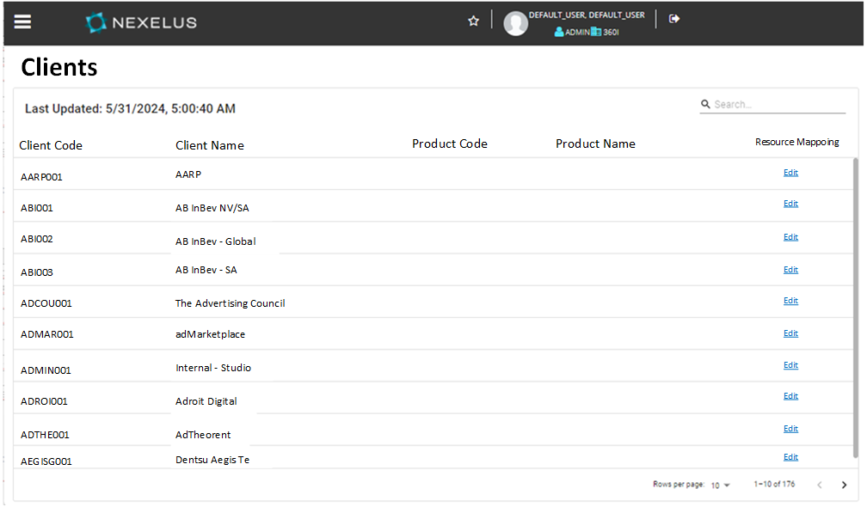

##### Role, Resource, and Service Mapping

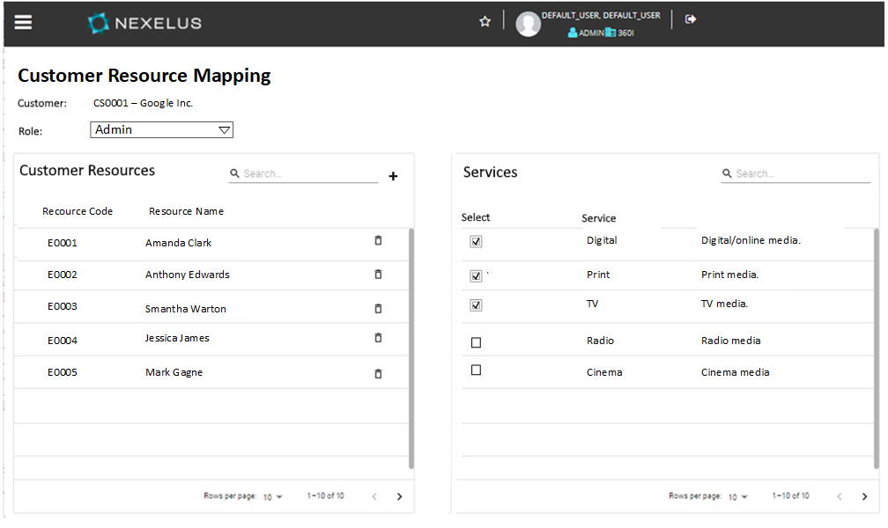

*Mapping for Customer Role, Resources, and Services*

The user must assign Resources for each Customer and then provide mapping to media/service types.